AWS Task-3

Task Description:

- Create a S3 bucket, with no public access and upload files to the bucket & view the logs using cloudwatch for the uploaded files.

- Launch two ec2-instances and connect it to a application load balancer, where the output traffic from the server must be an load balancer IP address

Techstacks needs to be used :

- AWS S3
- AWS EC2
- AWS LoadBalancer

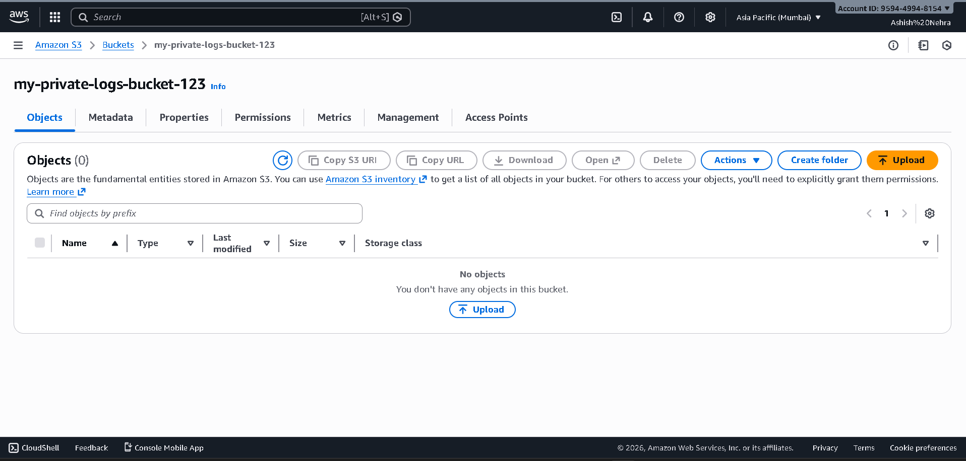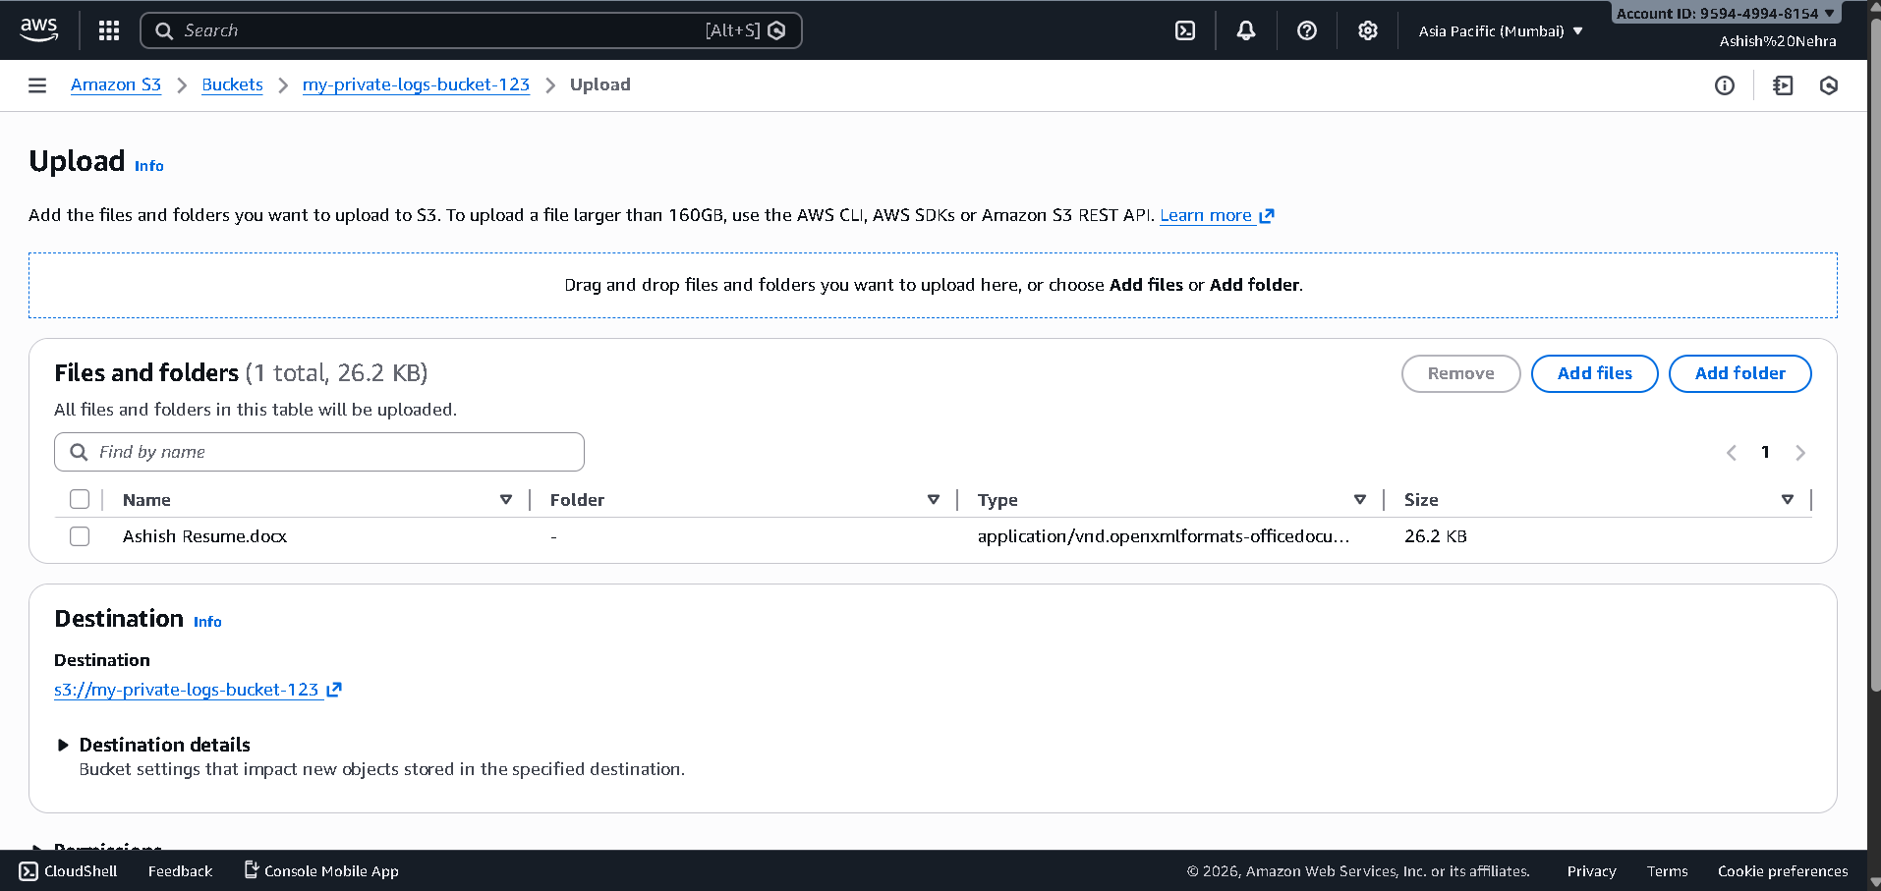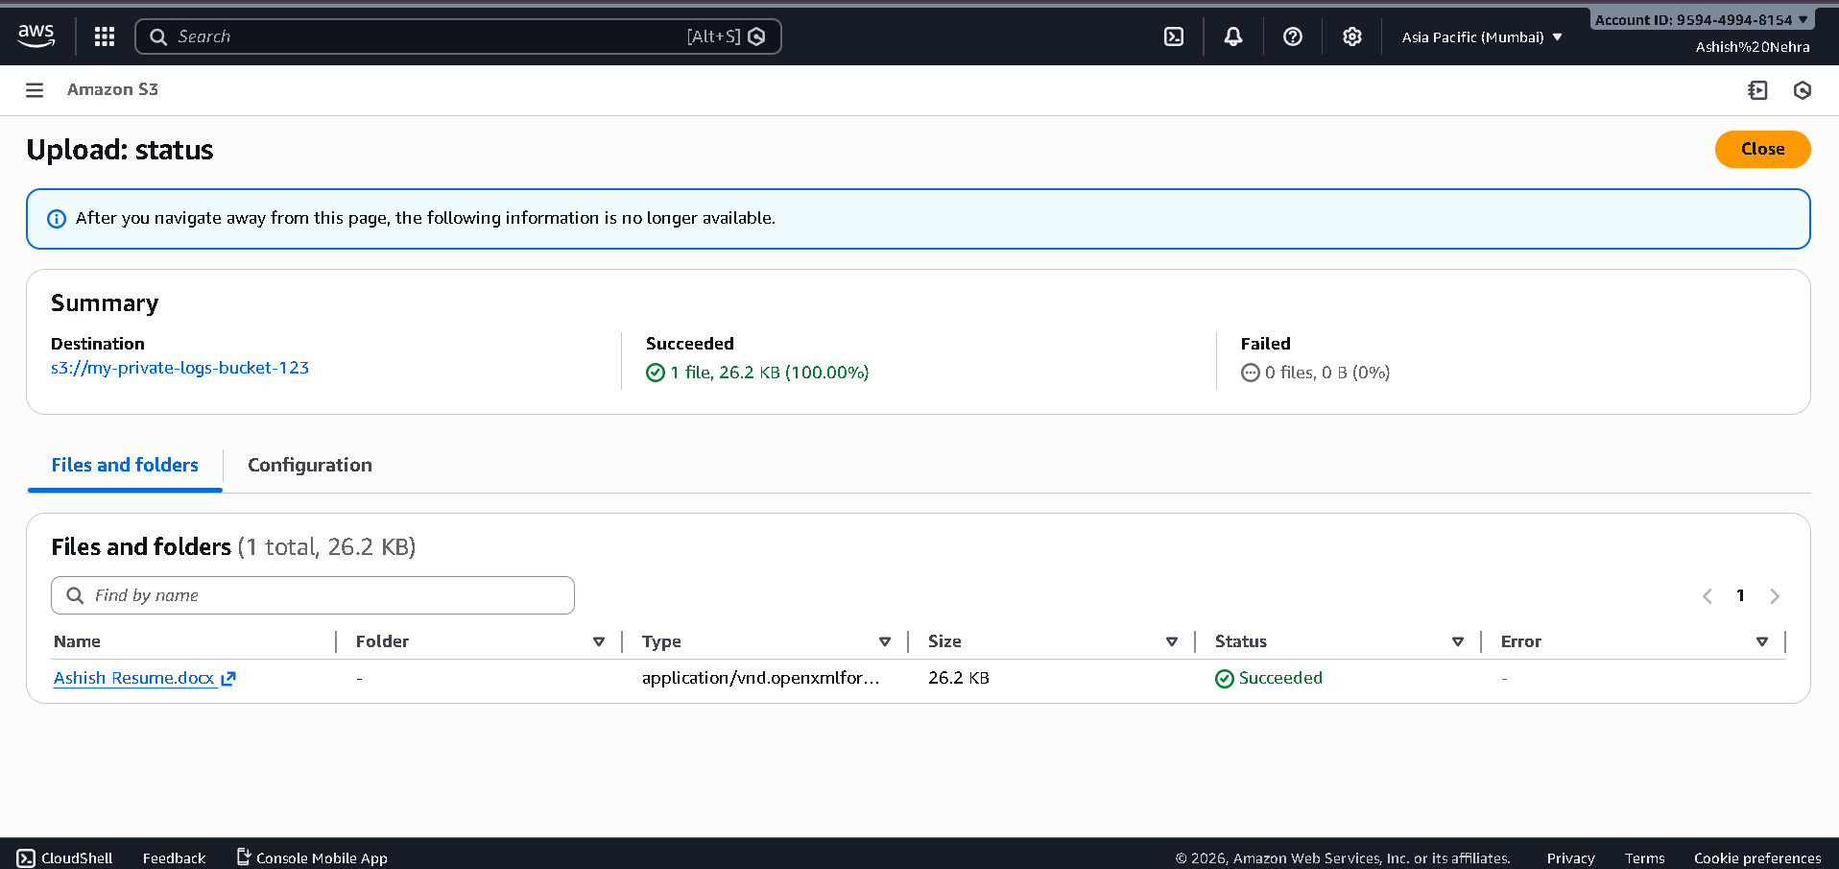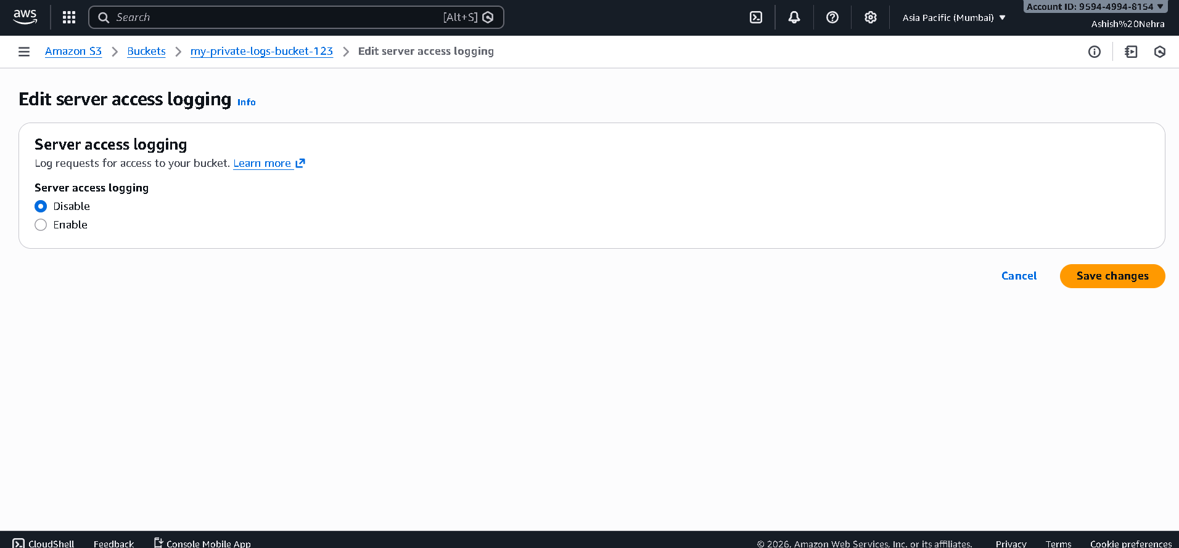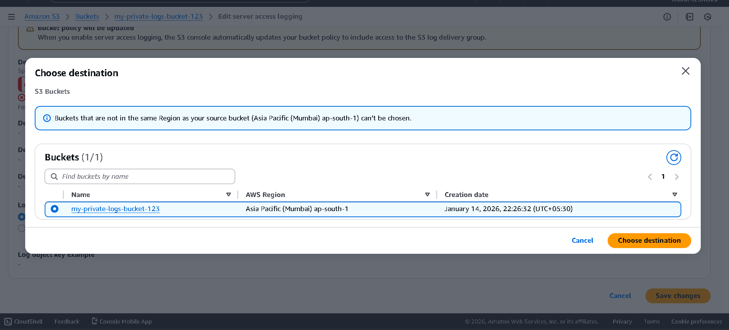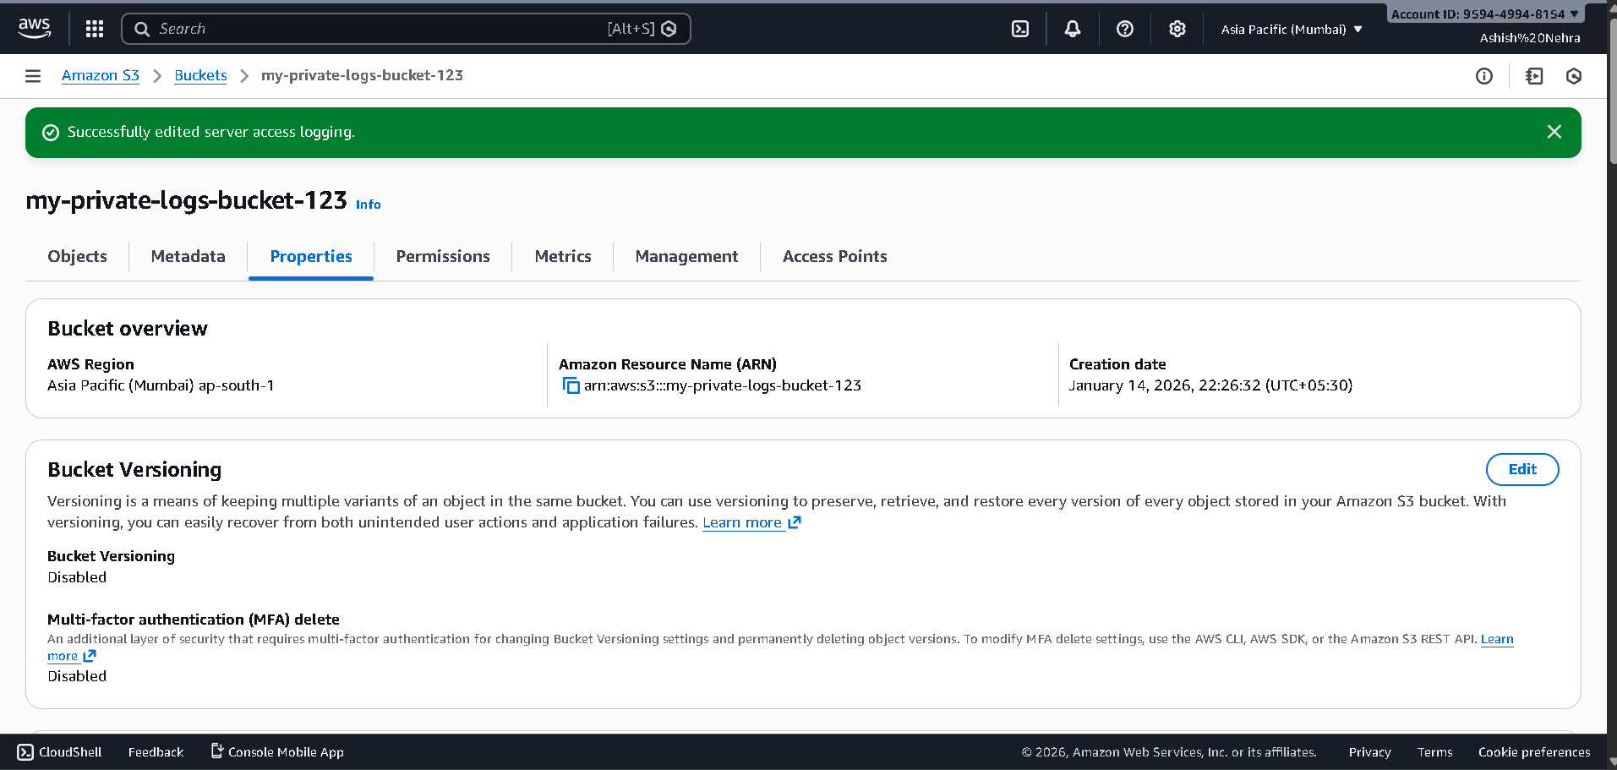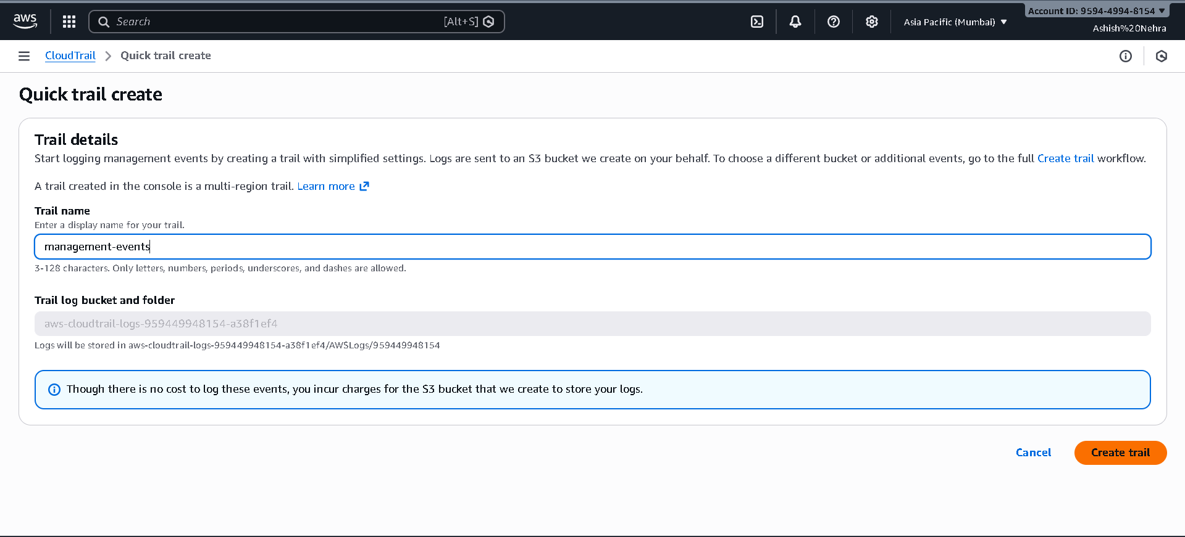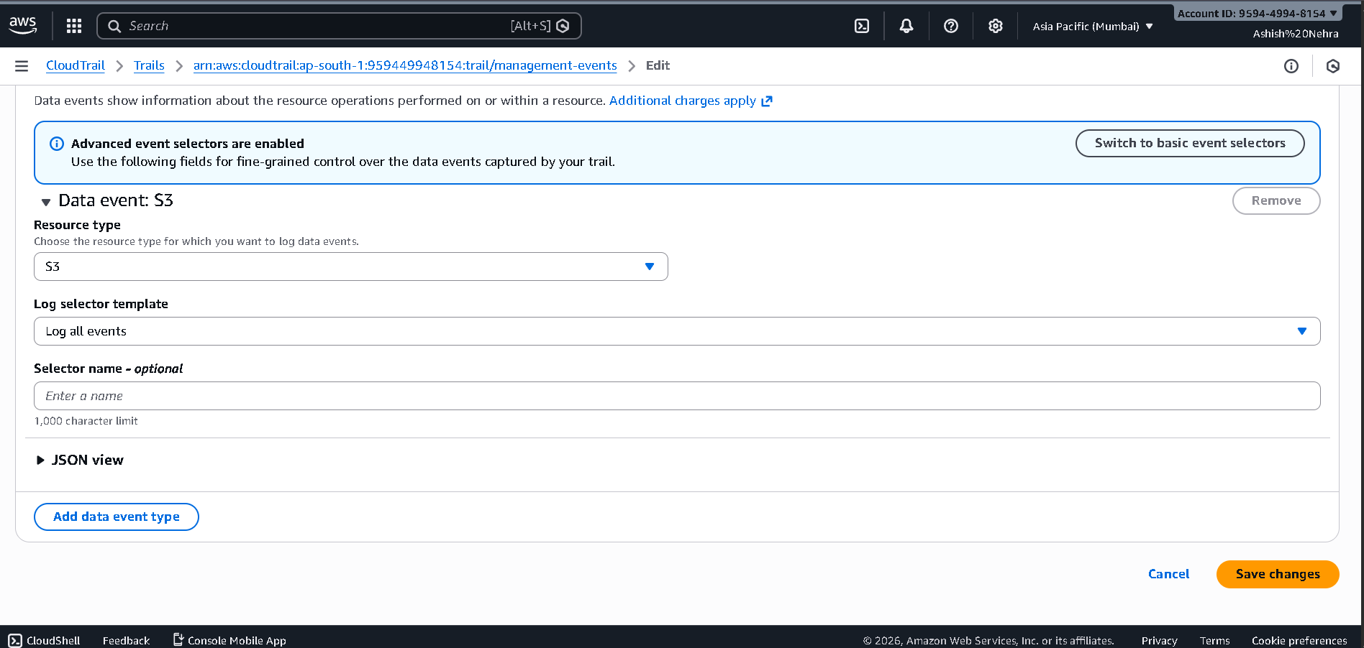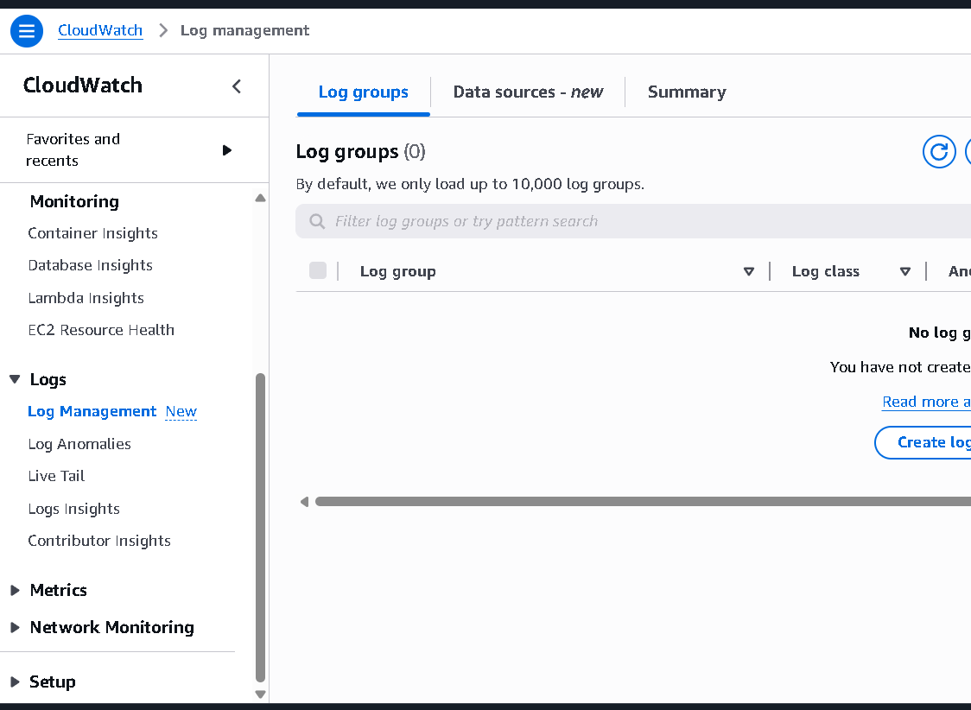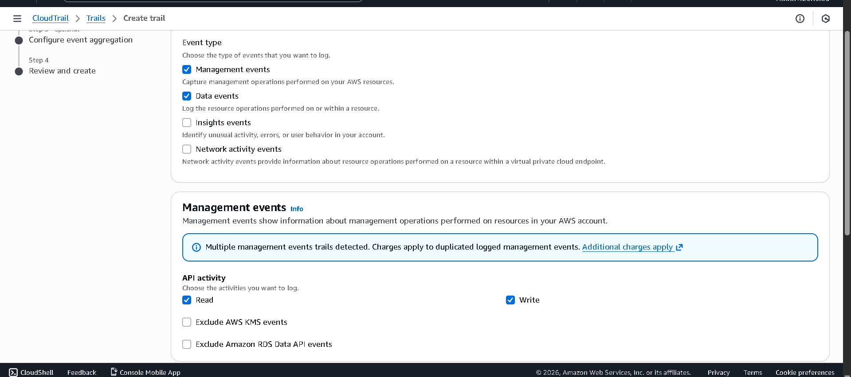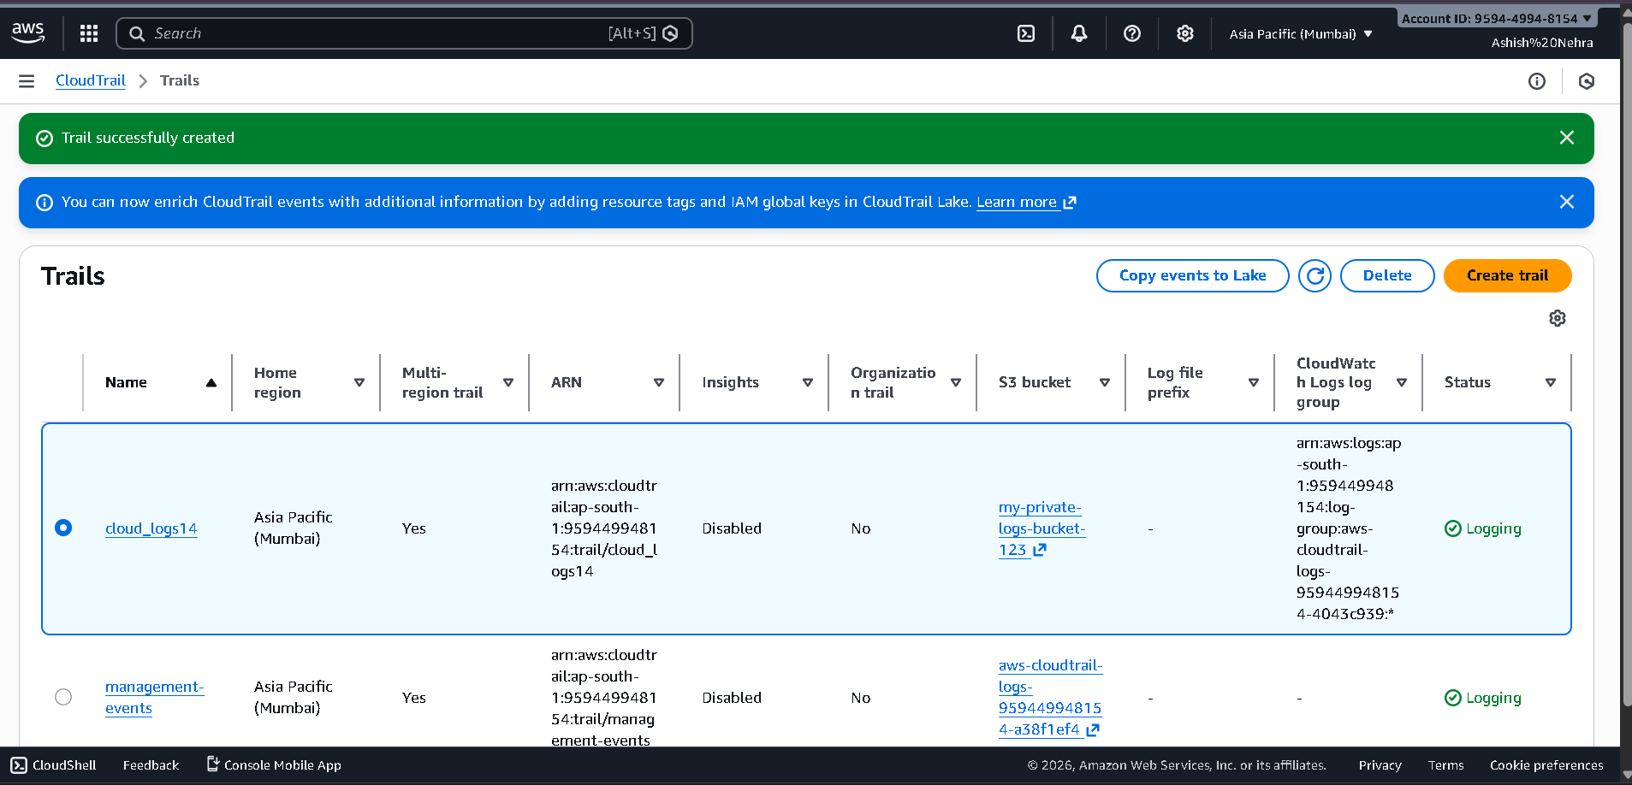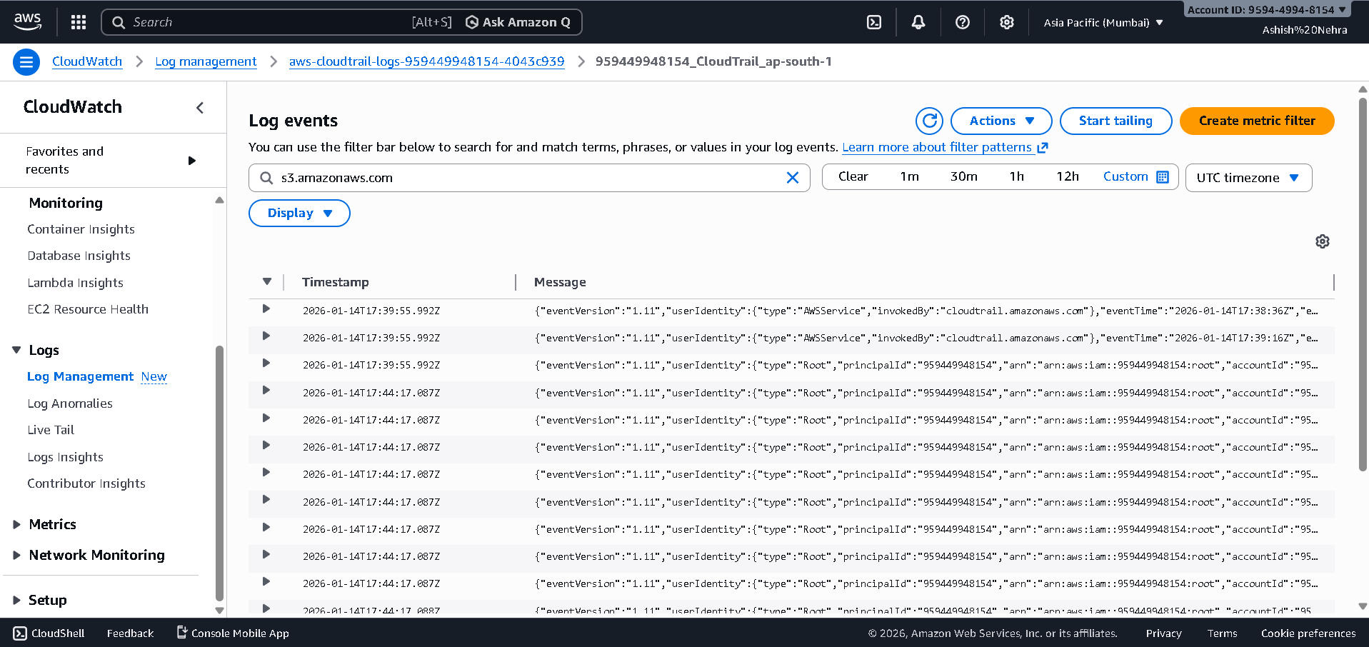

How do I submit my work?

- Push all your work files to GitHub (O/P screenshot images must).
- Submit your URLs in the portal.

Terms and Conditions?
- You agree to not share this confidential document with anyone.
- You agree to open-source your code (it may even look good on your profile!). Do not mention our company’s name anywhere in the code.
- We will never use your source code under any circumstances for any commercial purposes; this is just a basic assessment task.
NOTE: Any violation of Terms and conditions is strictly prohibited. You are bound to adhere to it.

